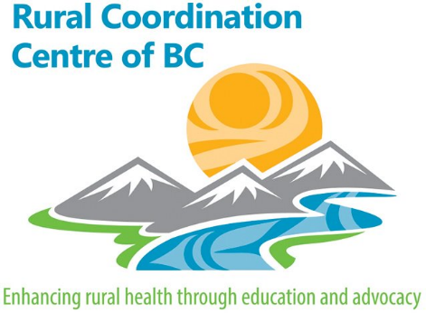
Real-Time-Virtual-Support (RTVS) for rural First Nations and remote communities: update.
The Collaborative Centre for Rural and First Nations Virtually Enhanced Care was established last year with support from Leadership Council. This is jointly supported and led by FNHA, Providence PHSA, and the RCCbc. It is guided by a Partnership Pentagram Plus table including geographic Health Authorities, Citizens, Academia, Rural Providers, Linked Sectors and Policy Makers. Its work has been focused around virtual care, while combatting the barriers posed by geography, distance, and weather to address health equity in BC. This forms an “Innovation Accelerator” within the Provincial Digital Health Strategy. All of these initiatives are locally driven and will be implemented in partnership. So where are we and what are we accelerating?
Virtual Care Platform Access: The JSC Has generously supported the provisioning of a virtual care platform for every rural doc and NP serving rural patients in BC. The choice of platform is driven by rural docs as the best fit at this point in time. We remain platform agnostic and have selected ZoomTM as one that can currently meet the needs of rural in connecting with patients, enlarging the healthcare team wrapped around patients and supporting ER services. Among other things this enables providers who may not be able to be physically present help carry some of the clinical workload for their teams. Accessing accounts for rural providers is available though the following link: https://rccbc.ca/zoom/ .
RUDi: In-time rural generalist ER support enabled virtually. One might see this as a rural virtual urgent primary care centre providing access to a physician who understands their context and supports the primary care and ER teams in rural communities. In particular we are working with FNHA to ensure support to remote First Nations communities with no access to primary care physicians.
ROSe: Virtual intensivist support 24/7 to rural ERs.
Virtual Locum Service: Working with the Rural Locum Programs of the Rural Joint Standing Committee (JSC) to offer a more flexible approach to locum support including linking locums with community (preferably with a connection to community).
Virtual First Call: We clearly are in a marathon not a sprint; where needed we are looking at the option of supporting virtual first call for smaller communities where the critical mass of providers to support 24/7 service may become strained.

